

**Midday Supervisor**

**Applicant Pack**

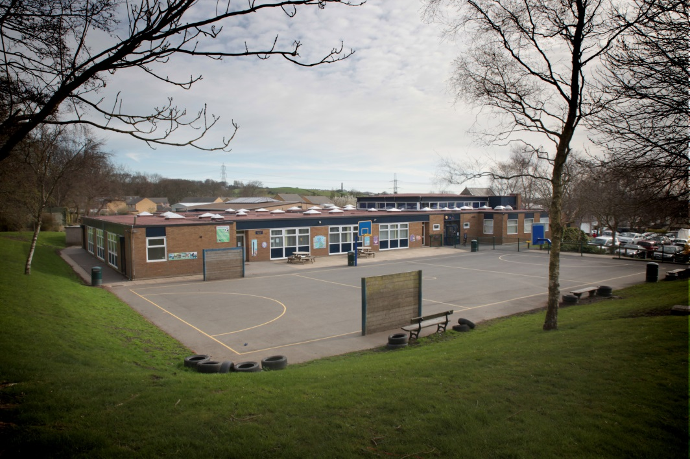

# CONTENTS

|  |  |
| --- | --- |
|  | **PAGE** |
| **Welcome letter** | **3** |
|  |  |
| **Advertisement** | **4** |
|  |  |
| **Timeline/How to apply** | **5** |
|  |  |
| **Safer Recruitment** | **6** |
|  |  |
| **Policy Statement on the**  **Recruitment of Ex-Offenders** | **7** |
|  |  |
| **Job Description** | **9** |
|  |  |
| **Person Specification** | **10** |

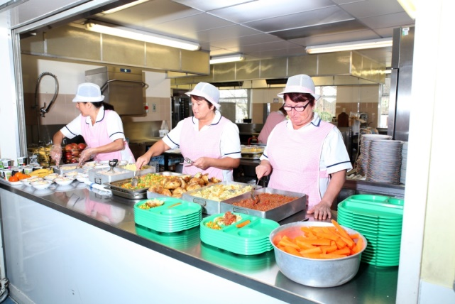



**INSPIRING SUCCESS**

**BEYOND EXPECTATION**

Headteacher: Mrs Jane Scardifield



August 2021

Dear Applicant,

Thank you for your interest in our Midday Supervisor vacancies and I am delighted that you have taken the time to download out application pack. The following documents are enclosed:

The following documents are enclosed:

* Advert
* Job Description
* Person Specification – this contains the essential and desirable criteria that the selection panel will be looking for and your application should address these accordingly

To apply for the vacancy – please complete our application form. This can be downloaded from our website: <http://northowram.calderdale.sch.uk/>

Please ensure that the application form is fully completed, paying particular attention to the employment history section. The information given must be in the specified format, i.e. dd/mm/yy. When providing details of referees one must be your current or most recent employer. References will not be accepted from relatives or from people writing solely in the capacity of friends.

The position advertised is for 7.5 hours per week (Monday to Friday – 11.30 a.m. to 1.00 p.m.)

We encourage and welcome visits to the school however due to Covid 19 and social distancing restrictions this may not be possible to visit the school, however if you would like to speak with a member of staff about the role please email [recruitment@northowram.calderdale.sch.uk](mailto:recruitment@northowram.calderdale.sch.uk) with your name and contact details and we will arrange a telephone call with you.

Northowram Primary School is committed to safeguarding and promoting the welfare of children, young people and vulnerable adults and expects all staff and volunteers to share this commitment. The successful applicant will be required to undertake pre-employment checks including references from previous employers, confirmation of right to work in the UK and a DBS check.

I look forward to receiving your application.

Yours sincerely



Jane Scardifield

Headteacher



**Northowram Primary School**

**Baxter Lane**

**Northowram**

**HX3 7EF**

**Tel: (01422) 202704**

**MIDDAY SUPERVISOR**

**7.5 hours per week Term Time + 1 Day**

**(Scale 1b - Points 1-2 £9.25 - £9.43 per hour)**

We are looking to appoint two Midday Supervisors to our successful lunchtime team. The successful candidates will be required to supervise pupils during their lunch break and must be willing to engage in play activities with the children and oversee various group games in the playground.

We would like to hear from you if you:

* have enthusiasm and enjoy working with children
* are a good communicator
* have a calm manner
* work well as part of a team

***The school is committed to safeguarding and promoting the welfare of children, young people and vulnerable adults and expects all staff and volunteers to share this commitment. Applicants to posts that are exempted from the Rehabilitation of Offenders Act will require a DBS check from the Disclosure and Barring Service before the appointment is confirmed, in addition to standard pre-employment checks.***

You can apply for this vacancy by downloading the application form and supporting documents from the Calderdale Council website [www.calderdale.gov.uk](http://www.calderdale.gov.uk) or from our website <https://northowram.calderdale.sch.uk/>

We encourage and welcome visits to the school however due to Covid 19 and social distancing restrictions this may not be possible, however if you would like to speak with a member of staff about the role please email [recruitment@northowram.calderdale.sch.uk](mailto:recruitment@northowram.calderdale.sch.uk) with your name and contact details and we will arrange a telephone call with you.

Please return your application form via e-mail: [recruitment@northowram.calderdale.sch.uk](mailto:recruitment@northowram.calderdale.sch.uk) or alternatively post to the school no later than **9am on Friday 27th August**. Late applications and CV’s will not be accepted.

# Timeline

Completed applications should be returned (via e-mail or hard copy) no later than 9am on Friday 27th August.

# Assessment/Interviews

W/c 30th August/ w/c 6th September

# How to Apply

Please complete the application form provided. The Personal Statement should be no longer than 2 sides of A4 and should address the selection criteria detailed in the person specification. Please note that any supplementary submissions in excess of these limits will be disregarded.

Prior to submitting an application, please check that you meet the essential criteria with regard to essential qualifications requested. If you are invited to interview you will be expected to bring your original educational certificates with you.

Please e-mail your completed application (subject heading: “Confidential – Midday Supervisor” to:

[recruitment@northowram.calderdale.sch.uk](mailto:recruitment@northowram.calderdale.sch.uk)

Applications will also be accepted by post.

If applying by post, please mark the envelope “Confidential – Midday Supervisor” and return to:

Northowram Primary School, Baxter Lane, Northowram, Halifax, HX3 7EF

# Communication

E-mail is our preferred method of communication. Candidates will receive all communication via their e-mail address and we would advise you to check your e-mails on a regular basis.

# Acknowledgement of receipt of applications

We do not acknowledge receipt of paper applications. Applications submitted on line will however, receive an acknowledgement upon request.

# Shortlisted Candidates

Shortlisted candidates will be contacted shortly after the closing date. If you do not hear from us within 4-6 weeks, please assume that on this occasion your application has been unsuccessful.

# Safer Recruitment

Safer recruitment practice aims to minimise the risk of appointing an individual who is unsuitable to work in a post where they will be in contact with children or vulnerable adults and could cause them harm. This school is fully committed to the principles of safer recruitment

Our selection processes observe best practice in selecting the appropriate candidate by ensuring equality of opportunity for all applicants whilst excluding any who may be unsuitable to work with our children. All candidates are expected to understand their own duties and responsibilities in regard to child protection and safeguarding with due relevance to the specific post advertised.

The Disclosure and Barring Service (DBS) helps employers to make safer recruitment decisions and to prevent unsuitable people from working with vulnerable groups, including children. It is a criminal offence to offer (or indeed to apply for, or to accept an offer of) employment in certain designated posts (those which involve working with children in what is defined as regulated activity) to a barred individual.

Accordingly, some or all (depending on the precise role) of the following steps will be taken as part of the recruitment processes:

* Confirmation of identity by sight of original official documents (Birth Certificate, Passport etc)
* Confirmation of professional qualifications (those required to fulfil the post) by sight of original documentation.
* Full scrutiny of employment history with clarification to be sought (from candidate or referees as appropriate) in the event of identified gaps or discrepancies.
* Satisfactory references – a minimum of two written references (one of which must be from most recent employer) will be taken up prior to interview.
* The identity of all referees must be open to verification.

In accordance with DBS regulations all candidates for relevant posts are required to provide details of any relevant unspent convictions. Additionally, for those posts involving “regulated activity”, all “spent” convictions must be disclosed under the Rehabilitation of Offenders Act 1974.

* A DBS check will be requested for appointments to all relevant posts.
* For those involved in “regulated activity” this will include an additional check of the Children’s Barred List.

Any conditional offer of employment will be made strictly subject to receipt of all required documentation (as specified) and satisfactory verification of all checks as above.

# Northowram Primary School

# Policy statement on the recruitment of ex-offenders

New legislation now requires all registered bodies and prospective employers to ensure that any applicants, subject to Disclosure and Barring Scheme (DBS) checks, who have a criminal record must not be unfairly discriminated against because of a conviction or other information revealed.

In addition registered bodies and employers who undertake Regulated Activity (Schools) must have a written policy on the recruitment of ex-offenders, a copy of which can be given to DBS applicants at the outset of the recruitment process.

As a Regulated Activity provider (RAP) all paid employees at Northowram Primary School provide regulated activity and are therefore subject to checks with the DBS.

This policy statement should be read alongside our Equal Opportunities policy.

# Policy Statement

As an organisation using the Disclosure and Barring Service (DBS) checking service to assess applicants’ suitability for positions of trust, Northowram Primary School complies fully with the Code of Practice. We undertake not to discriminate unfairly against any subject of a DBS check on the basis of a conviction or other information revealed.

Northowram Primary School is committed to the fair treatment of its staff, potential staff or users of its services, regardless of race, gender, religion, sexual orientation, responsibilities for dependants, age, physical / mental disability or offending background.

Northowram Primary School actively promotes equality of opportunity for all with the right mix of talent, skills and potential and welcome applications from a wide range of candidates, including those with criminal records. We select all candidates for interview based on their skills, qualifications and experience.

In relation to volunteers and contractors, we only request a DBS check after a thorough risk assessment has indicated that one is both proportionate and relevant to the position concerned.

For those positions where a DBS check is required, all application forms, job adverts and recruitment briefs will contain a statement that a DBS check will be requested in the event of the individual being offered the position.

We encourage all applicants called for interview to provide details of their criminal record at an early stage in the application process. We request that this information is sent (under separate, confidential cover) to the Head teacher and we guarantee that this information will only be seen by those who need to see it as part of the recruitment process.

We ensure that all those in our school who are involved in the recruitment process have been suitably trained to identify and assess the relevance and circumstances of offences. We also ensure that they have received appropriate guidance on the relevant legislation relating to the employment of ex-offenders, e.g. the Rehabilitation of Offenders Act 1974 and know how to access advice and support e.g. from our HR service, registered body, the DBS, etc.

At interview, or in a separate discussion, we ensure that an open and measured discussion takes place on the subject of any offences or other matter that might be relevant to the position. Failure to reveal information that is directly relevant to the position sought could lead to withdrawal of an offer of employment.

We undertake to discuss any matter revealed in a DBS check with the person seeking the position before withdrawing a conditional offer of employment. This discussion and any subsequent risk assessment may be undertaken by senior leaders in school or by our HR service.

**JOB DESCRIPTION**

The information given on this job description is intended to provide an understanding and appreciation of the workload of this particular job and its purpose within the organisation.

The job description outlines the main duties and responsibilities under broad headings only, as it is not possible to specify every item in detail. The post holder may be required to carry out any other duties as directed; the responsibility level of any other duties should not exceed those outlined below.

**SERVICE: Northowram Primary School**

**POST TITLE: Midday Supervisor**

**GRADE: Scale 1b**

**PRIME OBJECTIVES OF THE POST**

Under the direction of senior staff the postholder will supervise and assist pupils during the midday break to ensure their safety and general welfare. In addition, the postholder must encourage pupils to display appropriate behaviour inside and outside the school premises.

**RESPONSIBLE TO**

Senior Midday Supervisor

**MAIN DUTIES AND RESPONSIBILITIES**

1. To supervise all pupils throughout the school lunchtime period following a designated rota system.
2. To encourage children to eat healthily, to assist those who need help (such as cutting up food) and to ensure that pupils at all times behave appropriately in line with the school’s behaviour policy whether in the dining room, the playground or during wet lunch times.
3. To be aware of safeguarding protocols, taking appropriate action as necessary.
4. To supervise cloakroom and toilet areas.
5. To ensure that pupils are appropriately dressed for the weather conditions.
6. To promote positive values, attitudes and good pupil behaviour, dealing promptly with conflict and incidents in line with established policy and encouraging pupils to take responsibility for their own behaviour.
7. To ensure that groups of pupils are directed and escorted to designated areas of school.
8. To adhere to the school’s Health and Safety policy, providing guidance for the pupils as necessary.
9. To take reasonable precautions whilst in charge of pupils to prevent injuries.
10. To ensure in the event of sickness or injuries to pupils that they are dealt with in accordance with the school’s policies.
11. To organise games and ensure that pupils are active in purposeful, positive activities throughout the lunchtime period.
12. To supervise the clearing and cleaning of tables.
13. To act as a positive role model for pupils.

**GENERAL**

1. To attend meetings as required by the line manager.
2. To support the ethos and culture of the school.
3. To take part in any Continual Professional Development (CPD) and appraisal activities appropriate to the role.
4. To support the implementation of initiatives and policies, eg data protection, child protection including knowledge of the Designated Safeguarding Lead, health and safety and safeguarding policies etc.
5. To undertake any other professional duties as required by their line manager.

**PERSON SPECIFICATION**

**Note to Applicants:**

Criteria marked as essential are the key requirements. You should pay particular attention to these areas and provide evidence of meeting them. Failure to do so may mean that you will not be invited for interview.

Achievement of criteria – key to identification

A = Application I = Interview E = Exercise R = Reference

|  |  |  |  |
| --- | --- | --- | --- |
| **Qualifications and Training** | **Essential** | **Desirable** | **How**  **identified** |
| GCSE English or equivalent | 🗸 |  | A |
| Level 2 Award in Support Work in Schools |  | 🗸 | A |
| Current First Aid qualification or willing to undertake | 🗸 |  | A |
| **Experience** | **Essential** | **Desirable** | **How**  **identified** |
| Demonstrable experience of working with or caring for children of a relevant age | 🗸 |  | A/I |
| Demonstrable experience of organising children’s activities | 🗸 |  | A/I |
| Previous work in a school environment |  | 🗸 | A/I |
| **Knowledge and Skills** | **Essential** | **Desirable** | **How**  **identified** |
| Ability to use clear language to communicate information | 🗸 |  | A/I/E |
| Ability to promote the use of play and initiate games and activities | 🗸 |  | A/I |
| Ability to build positive working relationships with pupils and staff | 🗸 |  | A/I/R |
| Ability to follow instructions | 🗸 |  | A/I/E/R |
| Knowledge of child development |  | 🗸 | A/I/R |
| Up to date knowledge of safeguarding responsibilities and practices |  | 🗸 | A/I/R |
| **Initiative** | **Essential** | **Desirable** | **How**  **Identified** |
| Ability to follow safeguarding and health and safety procedures | 🗸 |  | A/I/R |
| Understanding the need to respect confidentiality | 🗸 |  | A/I/R |
| Willing to participate in training | 🗸 |  | A/I/R |

***Northowram Primary School is committed to safeguarding and promoting the welfare of children, young people and vulnerable adults and expects all staff and volunteers to share this commitment. Applicants to posts that are exempted from the Rehabilitation of Offenders Act will require a DBS check from the Disclosure and Barring Service before the appointment is confirmed.***